Bearing maximises service life for starter-generator bearings

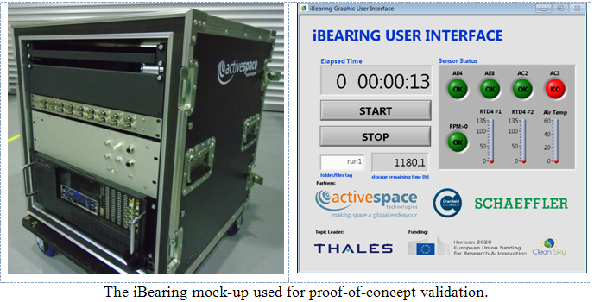

**An advanced sensor-enabled monitoring system that accurately gauges the health of critically important bearings that operate within harsh high-temperature environments will enable aero-engine starter generators to operate safely at higher speeds, thereby reducing fuel burn and contributing to ACARE goals. Clean Sky's iBearing project brings real-time monitoring intelligence to bearings, making European aviation safer and more environmentally friendly.**

Bearing condition monitoring is vital when it comes to rotary machine applications – indeed the consequences of bearing failure in mission-critical applications in aircraft can be catastrophic.  
But it's difficult to predict when they are likely to fail because of their small size and inaccessibility once installed in an engine. Clean Sky's iBearing (Instrumented Bearing For Oil Cooled Starter/Generator) 26 month project, coordinated by Active Space Technologies with support from Cranfield University and Schaeffler Technologies, focused on assessing fly-by-wire enabled technologies and smart sensors to monitor the integrity of bearings in real-time.

The project concluded last May after various candidate solutions had been designed, implemented and tested on the Schaeffler test rigs, resulting in a final iBearing product which is a miniaturized and integrated piece of equipment that can be installed in any bearing using minimal adaptation.

The ultimate aim of iBearing was to monitor the bearing in real-time while being subjected to a representative harsh environment characterized by oil lubricant and high temperatures. The proposed system applies an advanced data fusion algorithm capable of integrating sensorial data from several sources simultaneously, including temperature, low frequency accelerations, acoustic emission waves, and quality of the lubricant, in order to calculate the most reliable prediction of the time to failure, without intervention of any testing operator.

The project enables more accuracy in understanding the optimal window for servicing or changing engine starter-generator bearings, and aligns with the aero-industry shift in maintenance strategies which sees less reliance on fixed timeframes or operation cycles between maintenance procedures and a move towards sensor-based solutions, whereby component condition and wear become the determining factors for overhaul or replacement.

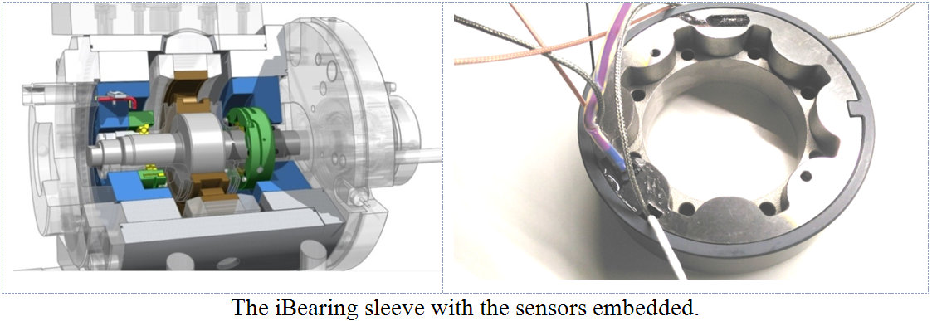

With iBearing, data collected from sensors embedded within the engine during flight allows operators to check temperature, pressure, vibration as well as acceleration and noise at any given moment which makes it viable to witness bearing degradation and mechanical wear and the onset of micro-cracking. Using live data to monitor the status of bearings in this way makes it possible to take appropriate pre-emptive maintenance measures.

Compact size, standalone operation and resilience to the aeroengine environment were essential to the design of a condition monitoring system able to measure the safe lifetime of the bearing and predict failure at least 100 hours in advance (with a statistical significance of 0.997 (i.e., 3 sigma), and the iBearing team succeeded in developing a prototype device for in situ monitoring of bearings able to endure the whole spectrum of rotational speed values throughout the different phases of flight – typically from 10,000 to 30,000 RPM. The prototype performance was tested in temperatures ranging between 150ºC and 200ºC and demonstrated encouraging results.

"The project is important for European aviation for several reasons" says António Santos of Active Space Technologies' Research and Development department, the coordinator of the iBearing project. "Firstly, more electrical power implies that generators must be larger or rotate at higher speeds. To mitigate the impact in the environment, the latter is recommended albeit high speed often implies more mechanical stress. Europe is leading environmental issues in the aviation sector and this project is a small contribution to keep the trend".

"Secondly, the aviation sector is steadily reducing maintenance costs, but at no expense of safety. Through-life engineering services is contributing to this effort, where state-of-the-art technologies and know-how assure that components are fully exploited within the context of their effective life span".

"Third, prediction of bearing failure in advance contributes to improve safety and maintenance planning, because monitoring can be performed not only on the ground but also during flight. Information of critical systems performance is important to further improve safety standards and reduce operational costs".

"Finally," concludes Santos, "by expanding the lifetime of vital systems, the aviation industry can safely expand the operational time of aircraft, thus reducing materials disposal and recycling needs".